**ADDING NETWORK ADAPTER’S**

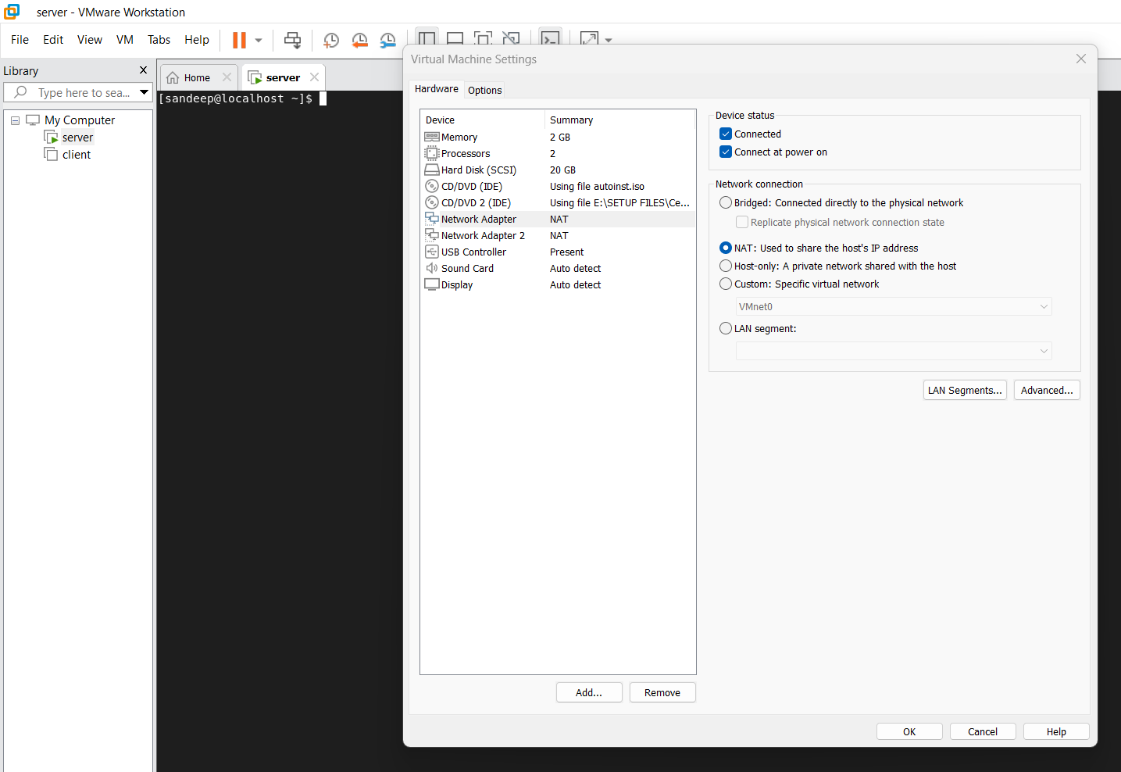

1. Go to the server option on the server folder Click Right button
2. Will get the setting then go to setting click on it, the will open.
3. In opened page select the **Network Adapter and give ADD**.

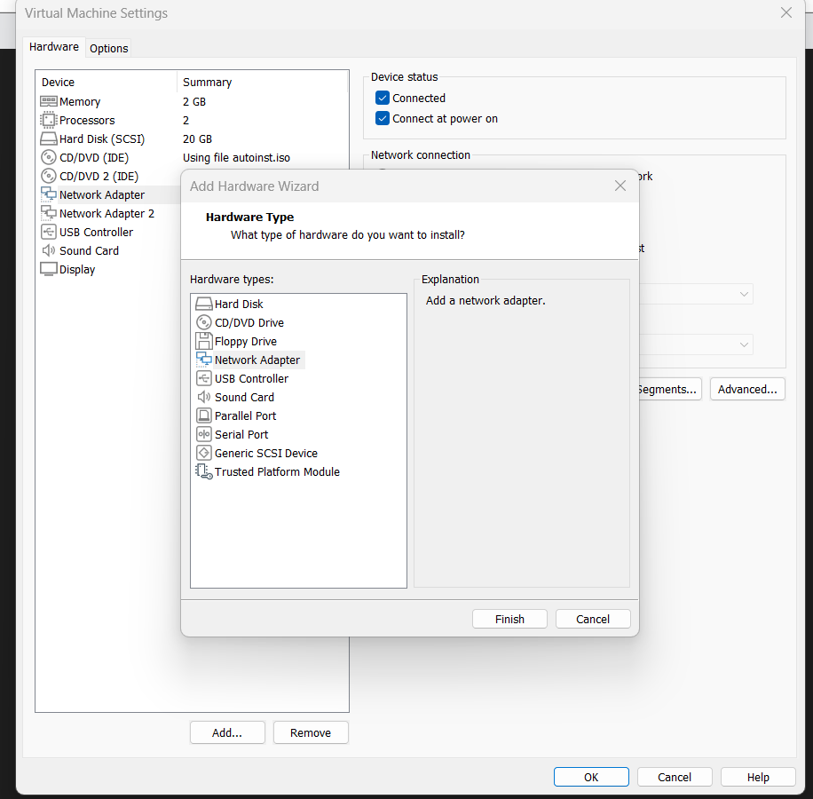

1. The page will open in that click on the Network Adapter give **finish and OK.**
2. Check whether the Network Adapter is added or no by using **command ifconfig**.
3. It will show the or list the Adapter list which contain the IP Add, Netmask & Broadcast details.

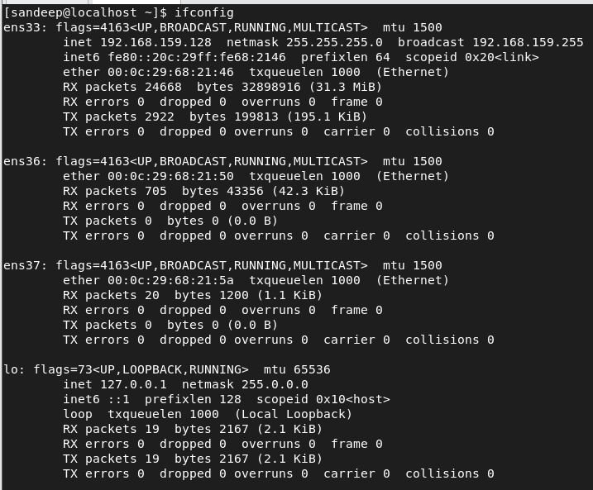

1. Use the CMMD **nmcli connection show**. Its shows the connection details.

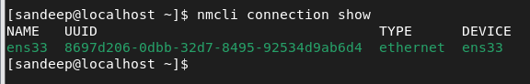

1. Use the CMMD for giving the dynamic IP.

**nmcli device connect ens37** and give the soft reboot.

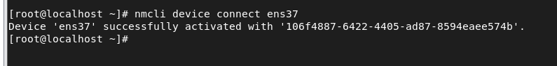

1. After giving soft reboot check the Adapter its got the Dynamic IP Address

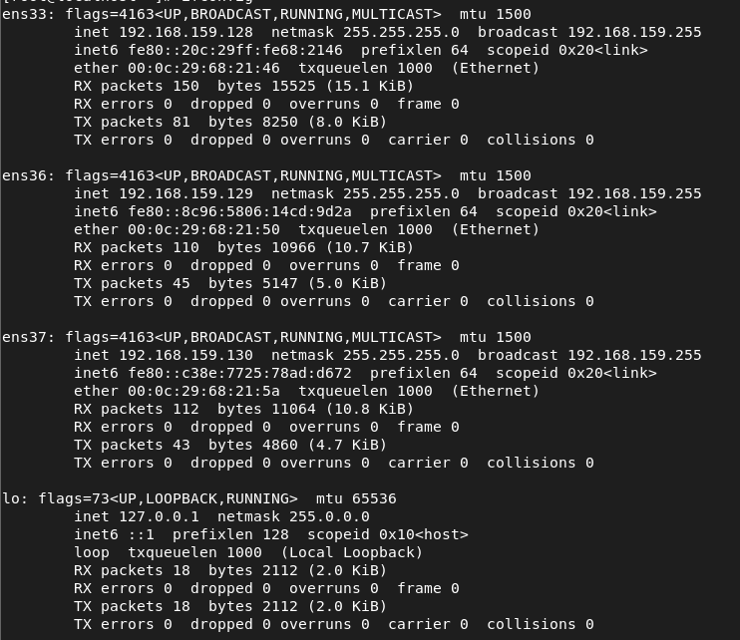

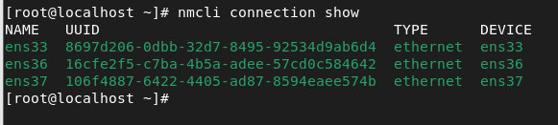

1. How to remove the Network device. We need to use CMMD.

nmcli device disconnection ens37

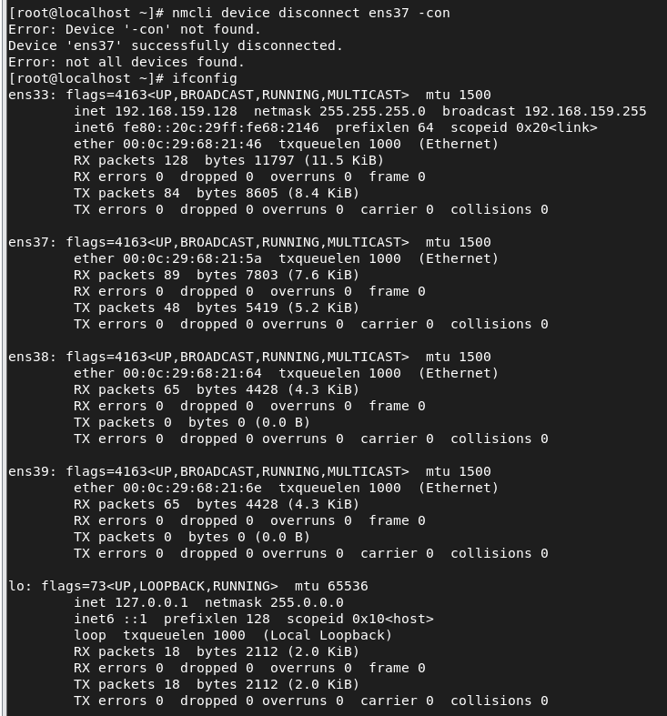

1. How to remove the Adapter. We need to use the CMMD.

nmcli con delete ens37

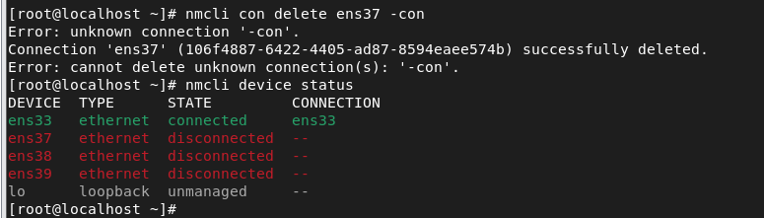

1. How to give the static IP for the New Adapter. We need to use the CMMD.

nmcli connection add type ethernet con-name ens38-con ifname ens38 ipv4.addresses 192.168.159.130/24 ipv4.gateway 192.168.159.2 ipv4.method manual autoconnect yes

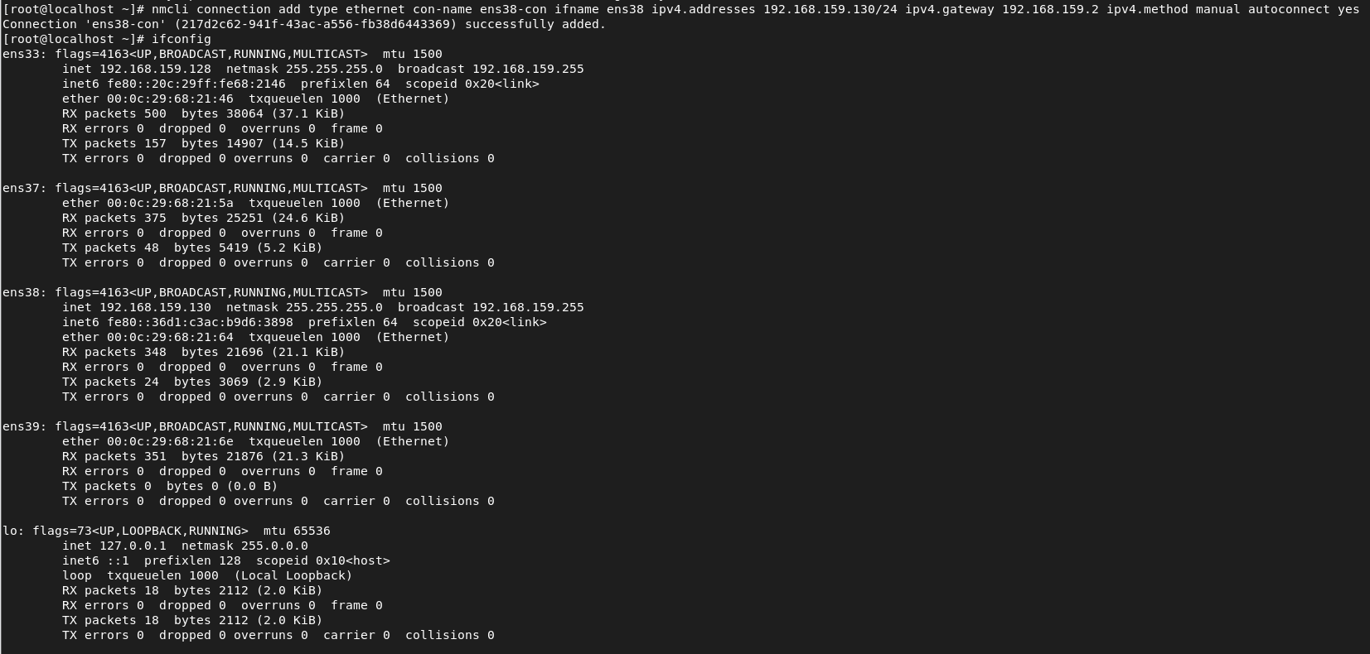

1. To check the list of connection.

nmcli connection show

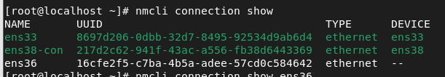

1. How to check the content in the Adapter .CMMD

nmcli connection show ens36

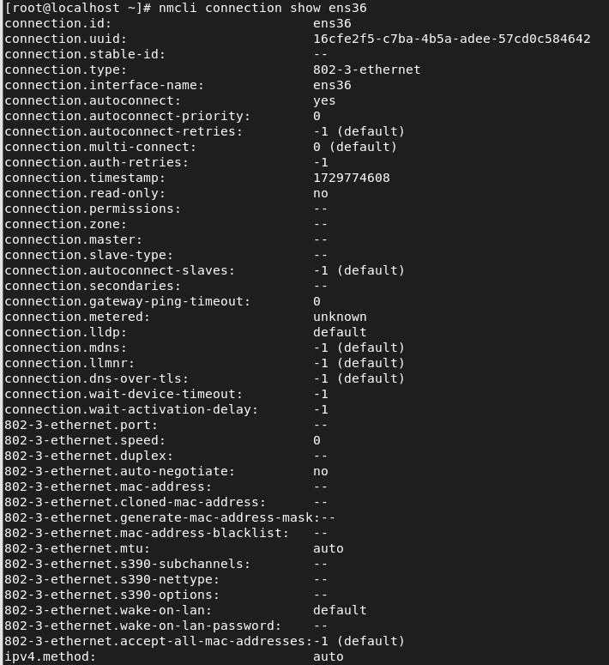

1. How to modify the connection in the Adapter.

CMMD

nmcli connection modify ens38 -con autoconnect no

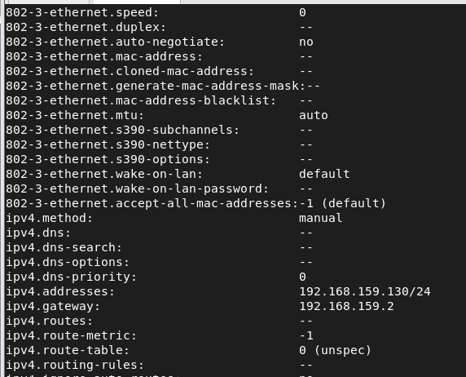

1. To make the adapter Down & Up the CMMD.

nmcli connection down ens38-con ; nmcli connection up ens38-con



1. To edit the Adapter.

nmcli con edit ens38-con

nmcli > print ipv4

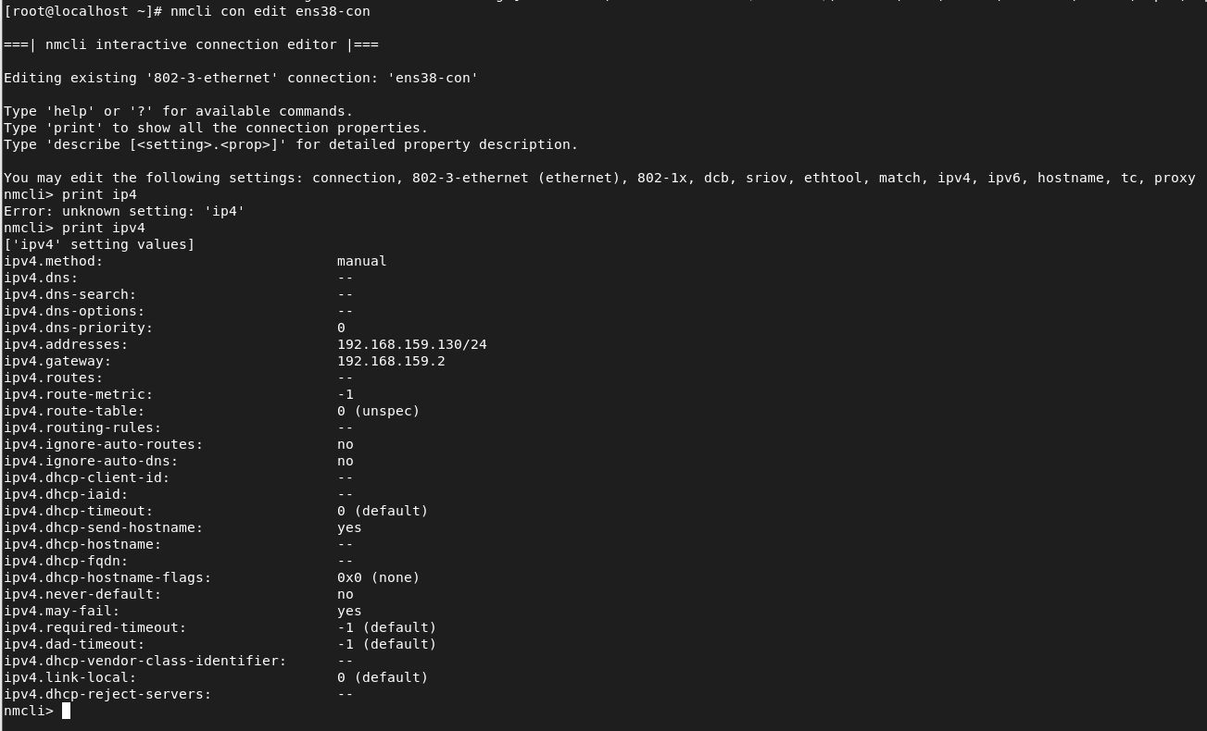

* To remove the IP from the particular Adapter

nmcli > remove ipv4 (need to put enter)

nmcli > save

nmcli> ipv4

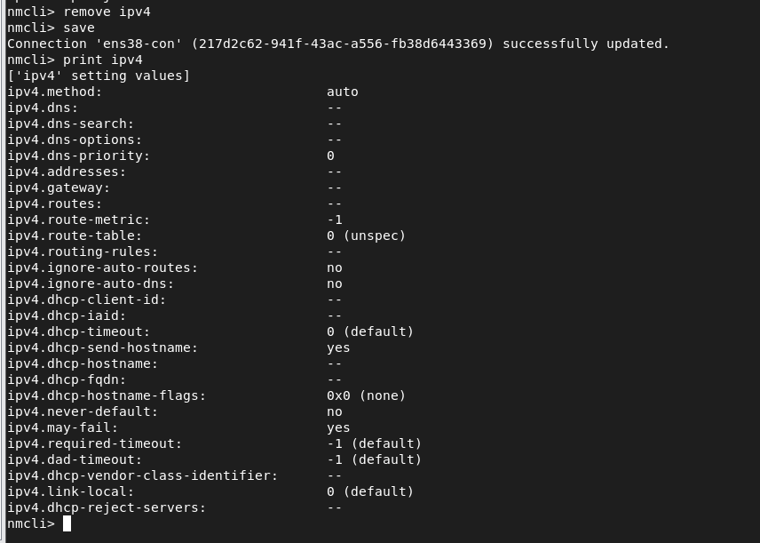

1. To disconnect & to delete the CON.

nmcli device disconnect ens38

nmcli con delete ens38-con

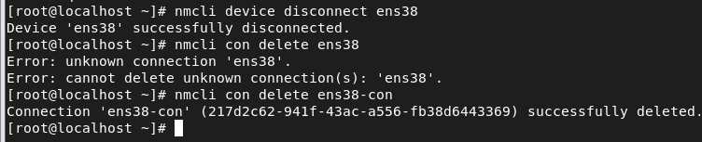

1. Check the details of the CON / Adapter.

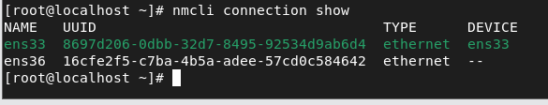

1. To Remove the Adapter

* Go to the server option on the server folder Click Right button
* Will get the setting then go to setting click on it, the will open
* In opened page select the **Network Adapter and give Remove**.
* Check whether the Network Adapter is removed or no by using **command ifconfig**

